Sriram.S and Suryanarayan.B

CB.EN.U4CSE19055 and CB.EN.U4CSE19056

Distributed Systems

Lab-Assignment-1

Question 1: Write an MPI Point –to -point C Program involving only 2 processes, where Node 1 sends the array of numbers to Node 0 in the communicating world.

Ans: #include <mpi.h>

#include <stdio.h>

#include <iostream>

using namespace std;

int main(int argc, char** argv) {

MPI_Init(&argc, &argv);

int world_size;

MPI_Comm_size(MPI_COMM_WORLD, &world_size);

int world_rank;

MPI_Comm_rank(MPI_COMM_WORLD, &world_rank);

if (world_rank == 0)

{

int b[5];

MPI_Recv(b, 5, MPI_INT, 1, 0, MPI_COMM_WORLD, MPI_STATUS_IGNORE);

for (int i = 0;i < 5;i++)

cout << b[i] << ",";

}

else

{

int a[10] = { 1,3,4,2,8,6,10,100,500 };

MPI_Send(a, 5, MPI_INT, 0, 0, MPI_COMM_WORLD);

}

MPI_Finalize();

}

Output:



Question 2: Write an MPI Point-to –point C program involving ‘n’ number of nodes in communicating world. The objective of this program is to find the sum of numbers from 1 to 1000. Each node in the communicating world should be assigned disjoint set of numbers between 1 and 1000. Each node should compute the sum of numbers assigned to it and communicate it to root node(I.e., node 0) to compute the overall summation value.Eg: Suppose Number of nodes (n) = 5Node 0Assigned with 1 to 200 Node 1 Assigned with 201 to 400 and so on.Final sum accumulated at Node 0 = 500500.

Ans: #include<stdio.h>

#include "mpi.h"

#include<iostream>

int main(int argc, char** argv)

{

MPI_Init(&argc, &argv);

//MPI_Status status;

int size;

MPI_Comm_size(MPI_COMM_WORLD, &size);

int rank;

MPI_Comm_rank(MPI_COMM_WORLD, &rank);

int i;

int sum1 = 0, sum2 = 0, sum3 = 0, sum4 = 0, sum5 = 0, sum;

if (rank == 0)

{

for (i = 1; i <= 200; i++)

{

sum1 = sum1 + i;

}

MPI_Recv(&sum2, 1, MPI_INT, 1, 6, MPI_COMM_WORLD, MPI_STATUS_IGNORE);

MPI_Recv(&sum3, 1, MPI_INT, 2, 7, MPI_COMM_WORLD, MPI_STATUS_IGNORE);

MPI_Recv(&sum4, 1, MPI_INT, 3, 8, MPI_COMM_WORLD, MPI_STATUS_IGNORE);

MPI_Recv(&sum5, 1, MPI_INT, 4, 9, MPI_COMM_WORLD, MPI_STATUS_IGNORE);

sum = sum1 + sum2 + sum3 + sum4 + sum5;

printf("This is Parent number %d from processors %d and got the final sum equal to %d", rank, size, sum);

}

else if (rank == 1)

{

for (i = 201; i <= 400; i++)

{

sum2 = sum2 + i;

}

MPI_Send(&sum2, 1, MPI_INT, 0, 6, MPI_COMM_WORLD);

printf("This is rank number %d sending the sum of 201 to 400 =>%d to rank 0", rank, sum2);

}

else if (rank == 2)

{

for (i = 401; i <= 600; i++)

{

sum3 = sum3 + i;

}

MPI_Send(&sum3, 1, MPI_INT, 0, 7, MPI_COMM_WORLD);

printf("This is rank number %d sending the sum of =>%d to rank 0", rank, sum3);

}

else if (rank == 3)

{

for (i = 601; i <= 800; i++)

{

sum4 = sum4 + i;

}

MPI_Send(&sum4, 1, MPI_INT, 0, 8, MPI_COMM_WORLD);

printf("This is rank number %d sending the sum of=>%d to rank 0", rank, sum4);

}

else if (rank == 4)

{

for (i = 801; i <= 1000; i++)

{

sum5 = sum5 + i;

}

MPI_Send(&sum5, 1, MPI_INT, 0, 9, MPI_COMM_WORLD);

printf("This is rank number %d sending the sum of=>%d to rank 0", rank, sum5);

}

MPI_Finalize();

}

Output:

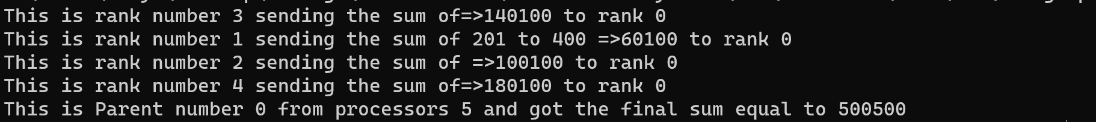

Question 3:Analyse the below code and write your observations

Ans: #include <mpi.h>

#include <stdio.h>

#include <stdlib.h>

int main(int argc, char** argv) {

int world_rank;

int world_size;

int token;

MPI_Init(NULL,NULL);

MPI_Comm_rank(MPI_COMM_WORLD, &world_rank);

MPI_Comm_size(MPI_COMM_WORLD, &world_size);

if (world_rank != 0) {

MPI_Recv(&token, 1, MPI_INT, world_rank - 1, 0, MPI_COMM_WORLD, MPI_STATUS_IGNORE);

printf("Process %d received token %d from process%d\n", world_rank, token, world_rank - 1);

}

else

{

token = - 1;

}

MPI_Send(&token, 1, MPI_INT, (world_rank + 1) % world_size, 0, MPI_COMM_WORLD);

if (world_rank == 0) {

MPI_Recv(&token, 1, MPI_INT, world_size - 1, 0, MPI_COMM_WORLD, MPI_STATUS_IGNORE);

printf("Process %d received token %d from process %d\n", world_rank, token, world_size - 1);

}

MPI_Finalize();

}

Output:

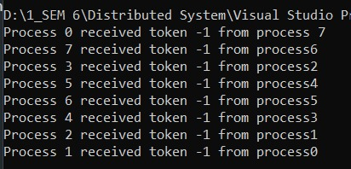

Inference:

The code passes the tokens to processes that are one rank higher than the current process and finally comes back to initial process.

We can say that process 0 will pass to 1, then 1 to 2, and so on until we reach n-1 and then return to 0.

Question 4: Write a MPI collective C program using the functions Bcast and Barrierinvolving n nodes in communication. Each node has part of the whole data, which the program mustbroadcast their part of the data to all the other nodes.

Ans: #include <stdio.h>

#include <stdlib.h>

#include <mpi.h>

int main(int argc, char* argv[])

{

MPI_Init(&argc, &argv);

// Get my rank

int my_rank;

MPI_Comm_rank(MPI_COMM_WORLD, &my_rank);

printf("[MPI process %d] I wait on the barrier.\n", my_rank);

MPI_Barrier(MPI_COMM_WORLD);

printf("[MPI process %d] I know all the processes have waited on this barrier.\n", my_rank);

int broadcast_root = 0;

int buffer;

if (my_rank == broadcast_root)

{

buffer = 45678;

printf("[MPI process %d] I am the broadcast root, and I send the value of %d.\n", my_rank, buffer);

}

MPI_Bcast(&buffer, 1, MPI_INT, broadcast_root, MPI_COMM_WORLD);

if (my_rank != broadcast_root)

{

printf("[MPI process %d] I am the broadcast receiver, and obtained the value of %d.\n", my_rank, buffer);

}

MPI_Finalize();

return EXIT_SUCCESS;

}

Output:

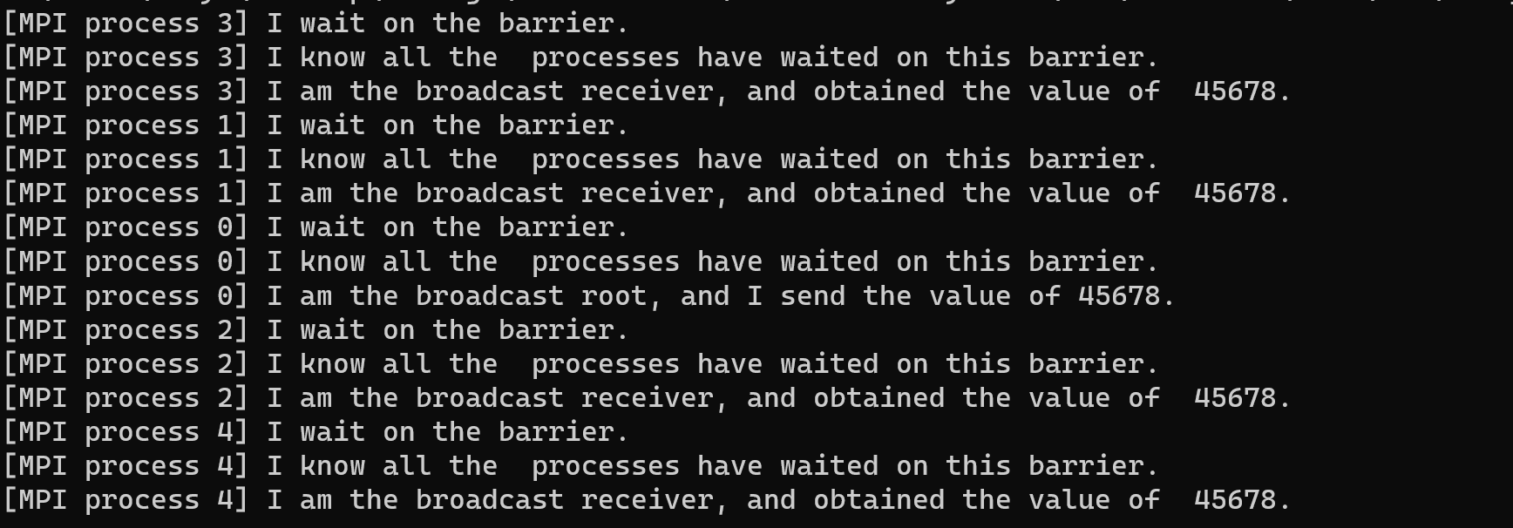

Question 5: Write a MPI collective C program that computes the average of an array of elements in parallel using (MPI_Scatter and MPI_Gather):

Ans: #include <stdio.h>

#include <stdlib.h>

#include <time.h>

#include <mpi.h>

#include <assert.h>

float* create_rand_nums(int num_elements) {

float* rand_nums = (float*)malloc(sizeof(float) * num_elements);

assert(rand_nums != NULL);

int i;

for (i = 0; i < num_elements; i++) {

rand_nums[i] = (rand() / (float)RAND_MAX);

}

return rand_nums;

}

float compute_avg(float* array, int num_elements) {

float sum = 0.f;

int i;

for (i = 0; i < num_elements; i++) {

sum += array[i];

}

return sum / num_elements;

}

int main(int argc, char** argv) {

if (argc != 2) {

fprintf(stderr, "Usage: avg num_elements_per_proc\n");

exit(1);

}

int num_elements_per_proc = atoi(argv[1]);

srand(time(NULL));

MPI_Init(NULL, NULL);

int world_rank;

MPI_Comm_rank(MPI_COMM_WORLD, &world_rank);

int world_size;

MPI_Comm_size(MPI_COMM_WORLD, &world_size);

float* rand_nums = NULL;

if (world_rank == 0) {

rand_nums = create_rand_nums(num_elements_per_proc * world_size);

}

float* sub_rand_nums = (float*)malloc(sizeof(float) * num_elements_per_proc);

assert(sub_rand_nums != NULL);

MPI_Scatter(rand_nums, num_elements_per_proc, MPI_FLOAT, sub_rand_nums,

num_elements_per_proc, MPI_FLOAT, 0, MPI_COMM_WORLD);

float sub_avg = compute_avg(sub_rand_nums, num_elements_per_proc);

float* sub_avgs = NULL;

if (world_rank == 0) {

sub_avgs = (float*)malloc(sizeof(float) * world_size);

assert(sub_avgs != NULL);

}

MPI_Gather(&sub_avg, 1, MPI_FLOAT, sub_avgs, 1, MPI_FLOAT, 0, MPI_COMM_WORLD);

if (world_rank == 0) {

float avg = compute_avg(sub_avgs, world_size);

printf("Avg of all elements is %f\n", avg);

float original_data_avg =

compute_avg(rand_nums, num_elements_per_proc * world_size);

printf("Avg computed across original data is %f\n", original_data_avg);

}

if (world_rank == 0) {

free(rand_nums);

free(sub_avgs);

}

free(sub_rand_nums);

MPI_Barrier(MPI_COMM_WORLD);

MPI_Finalize();

}

Output:

